1. Create Linux and docker installation
2. Create database

1. Copy the docker file and context file on the github.

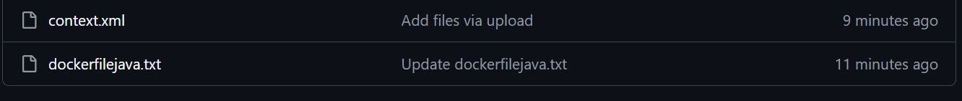

1. Install MYSQL on the Linux

1. Connect to Mysql:  
   mysql -h studentapp.cs7m8k6ia6ht.us-east-1.rds.amazonaws.com -u admin -pBasappa123  
   A black screen with white text

   AI-generated content may be incorrect.
2. Create database and table:

SHOW DATABASES;

USE student_db;  
  
CREATE TABLE `students` (

`id` bigint(20) NOT NULL AUTO_INCREMENT,

`name` varchar(255) DEFAULT NULL,

`email` varchar(255) DEFAULT NULL,

`course` varchar(255) DEFAULT NULL,

`student_class` varchar(255) DEFAULT NULL,

`percentage` double DEFAULT NULL,

`branch` varchar(255) DEFAULT NULL,

`mobile_number` varchar(255) DEFAULT NULL,

PRIMARY KEY (`id`)

) ENGINE=InnoDB AUTO_INCREMENT=80 DEFAULT CHARSET=latin1 COLLATE=latin1_swedish_ci;

1. Connect to github and goto the dockerfile path
2. Run the dockerbuild command:  
   docker build -t studentapp .  
     
   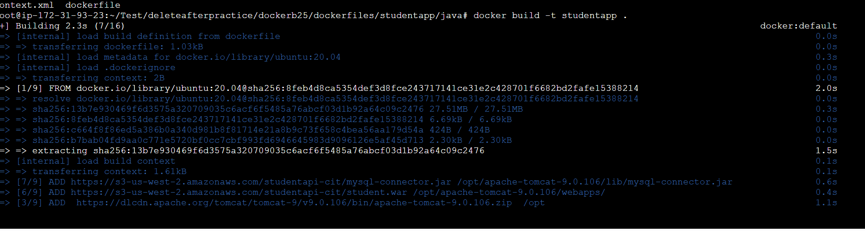
3. Docker run -d -P cont_ID